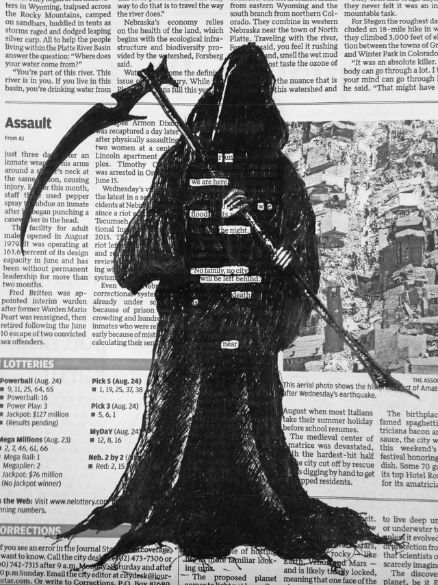

McDonald’s ENG 10- Creative Writing Assignment
BLACKOUT POETRY
What is “Blackout Poetry”?
Blackout poetry is when a page of text--usually an article from a newspaper-- is completely blacked out (colored over with permanent marker so that it is no longer visible) except for a select few words. When only these words are visible, a brand new story is created from the existing text.
How do I create a “Blackout poem”?
Unlike a research paper for school, when picking an article to use, it's best not to read it too closely. That way, you aren't overly influenced by the author's original work and you can create something uniquely your own. If you choose to blackout a novel, you are able to use other writers' stories to make your own; if you choose to use an article, you have the power to create fiction from non-fiction.

A good way to start is to glance at the page without reading the text fully and put boxes around the words or phrases that for whatever reason, really strike you. You can choose whether you want to make a broad story out of just "big" words like nouns, verbs, and adjectives or if you want to create a more coherent narrative using big words and little words like "is," "of," and "the" to move the story along…then, just blackout all the other words on the page. If you want to graduate to super advanced blackout poetry you can even create visual poetry out of the words you decide to keep and the ones you blackout.
See the example for inspiration!

