Story #1 “Sleeping Beauty”
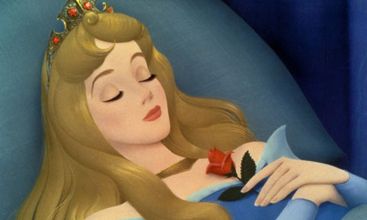
1. What do we know about the “old fairy”? (where she lives, her motivations and thoughts, her feelings about other characters…)
a______________________________________________________________________________________b______________________________________________________________________________________c______________________________________________________________________________________

2. Is the “old fairy” a Flat or Round character?_________________
3. How can you justify calling this character flat or round? ___________________________________________________________
4. Is the “old fairy” a static or dynamic character?_________________
5. How can you justify calling this character static or dynamic? ___________________________________________________________

Story #2
1. What do we know about the “bad fairy”? (where she lives, her motivations and thoughts, her feelings about other characters…)
a______________________________________________________________________________________b______________________________________________________________________________________c______________________________________________________________________________________
2. Is the “bad fairy” a Flat or Round character?_________________
3. How can you justify calling this character flat or round? ________________________________________________________________________
4. Is the “bad fairy” a static or dynamic character?________________
5. How can you justify calling this character static or dynamic? ________________________________________________________________________
6. In what ways do we feel sympathy for the “bad fairy”?
a____________________________________________________________
b____________________________________________________________ c____________________________________________________________
7. In what ways are the “bad fairy’s” actions justified?
a____________________________________________________________
b____________________________________________________________ c____________________________________________________________

