Edward Scissorhands Multi-paragraph Piece Outline
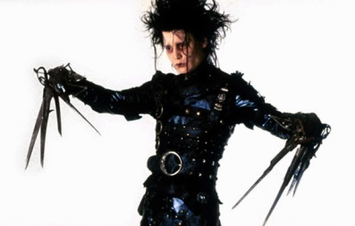
Thesis statement:
______________________________________________________________________________________________________________________________________

Topic Sentence #1:
______________________________________________________________________________________________________________________________________

Examples/quotes to be used to develop first main idea: (point form)
a.____________________________________________________________
b.____________________________________________________________
c.____________________________________________________________

Topic Sentence #2:
______________________________________________________________________________________________________________________________________

Examples/quotes to be used to develop second main idea: (point form)
a.____________________________________________________________
b.____________________________________________________________
c.____________________________________________________________

Topic Sentence #3:
______________________________________________________________________________________________________________________________________

Examples/quotes to be used to develop third main idea: (point form)
a.____________________________________________________________
b.____________________________________________________________
c.____________________________________________________________

Conclusion (re-statement of thesis in a new way):
______________________________________________________________________________________________________________________________________

